-Research online, found interesting in image generation.

DCGAN first

-Learned new technology which we can input a comic face and let machine draws fake human face, or input real person face, and output the comic face.

-After we build the model, input would be real picture, output the fake pic that machine draws. But we think we can have an improvement on it, so we decide to use the CycleGan.

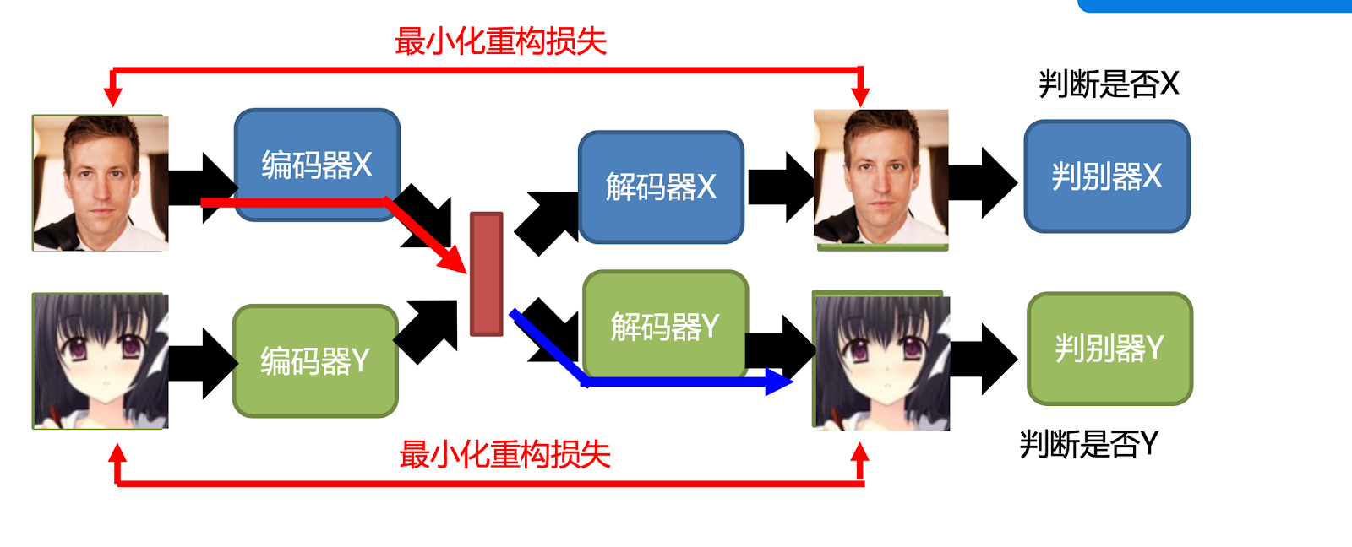

2 datasets are training at the beginning, and then we want to save their features on the right position (like the nose from one pic will not show up on the eyes position of another one). The encoder use convolution neural network to extract the features from the original dataset pics and save those features in a public space (red box). So the encoder will extract the pic A(real person)’s feature and put into the public space, and as well as B’s. Then decoder will put the A’s features on B, and B’s features on A and then output the result pics. Finally, discriminator going to distinguish output pics whether is real or not.

Problems: cannot deploy our preset model on to the web app

Solution: we setup tensorboard so that we can see our model for the entire project. (visualization tool)

// Whenever you setup a node, it will displayed on tensorboard.